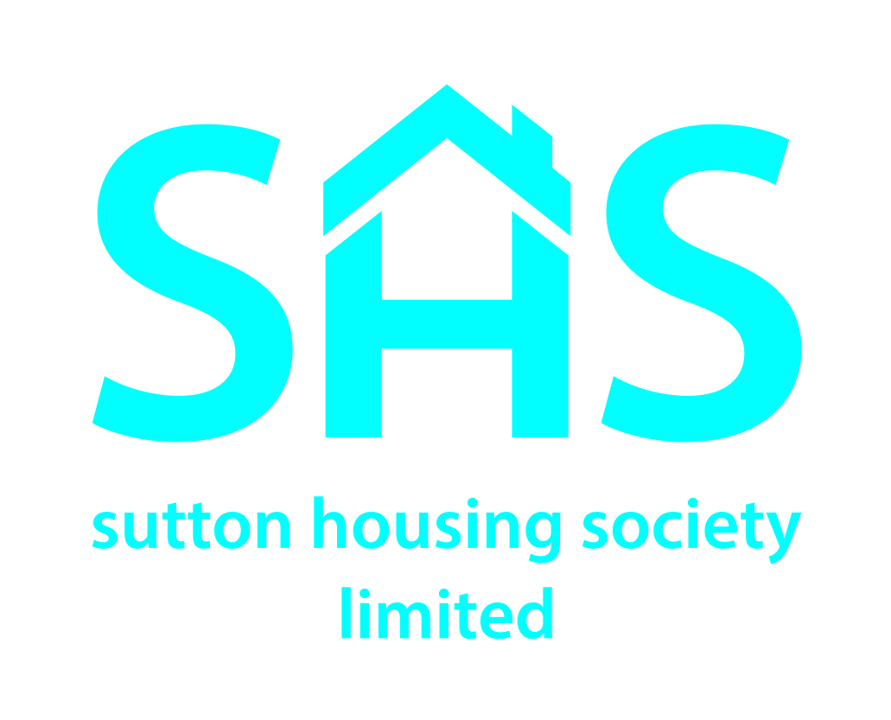

Board Members Needed

The work of Sutton Housing Society (a charitable housing association) is directed at a strategic level by our Board of Management. These voluntary members bring their skills and expertise from a wide range of fields to help ensure the Society meets its objectives.

Although experience in the provision of social housing is useful it is not a requirement. We are looking for members who can bring a range of skills to the role of a Board Member and who support the provision of social housing for rent.

Our Board meets five times per year in the evenings in Sutton.

Further details about Sutton Housing Society and its work can be found on our website.

If you are interested in the role, please contact Chris Turton (Chief Executive) on 0208 642 1500 or send an email to info@shsoc.org.uk for an informal discussion and more information.

