Contact Us  Any questions please contact the Community Engagement Officer  13-19 Ventnor Road  Pat Shaw House  Sutton  SM2 6AQ  Phone: 02089152952  Sutton housing society ltd.  13-19 Ventnor Road  Pat Shaw House  Sutton  SM2 6AQ |  |  | Guide to setting up and running a social committee  Sutton housing society ltd.  - Community Engagement

Table of Contents  The Guide 1  Getting Started 2  Roles explained  Events 3  Steps to planning your event 4  SHS involvement 5  Travelling between Schemes 6  Map of Schemes……………………………………………………….7  Scheme Address………………………………………………………8 |  |  |  | This Guide  Why has this been created?  This guide has been designed to help and aid the tenants of Sutton Housing Society in creating a social committee.  Each scheme should ideally have one social committee which are able to work with the community engagement officer, creating and running activities open to the residents  Why should I/We start a social committee?  If you have an idea about an activity or an event you’d like to put on a social committee is a great way to bring the community together. Trying to organize an event by yourself may be challenging and  How do I know if there is a social committee already at the scheme?  You will need to check your events noticeboard for any scheme committee posters or flyers.  There’s already an existing social club in my scheme?  Get involved! You may not want to/have the time for join the social committee; however you can still take advantage of the social events. Remember the activities are available to all tenants, across all the schemes. This guide will give you details on how to travel on public transport between the schemes.
 |  |  |  | 5
Getting Started  Setting up a social committee  So you’ve identified a need for a social committee at your scheme…  The next step will be to speak to other residents about getting involved. This could be done by word of mouth as your passing in the corridor, creating a letter but should result in holding an informal meeting in the communal area.  If you plan to hold a meeting, remember that a social committee shouldn’t be a chore and don’t overload it with too much information. You will need to think about a date and time that would be convenient for the majority to attend, e.g. if held during standard working hours those with a job wouldn’t be able to attend. You can ask the community engagement officer to help with the meeting. There should be a register of interest as to which individual should take on each of the following roles |  |  |  | Roles explained  Chairman  - Elected by the members of the committee  - Takes control of the meetings  - Ensures the committee meet  Secretary  - Takes the minutes of meetings  - Lets the committee know when and where the next meeting will be held  - Helps prepare for the events  Overall the idea of the secretary is that he/she keeps the committee members informed  Treasurer  - Keeps a record of money, e.g. fundraising  - Able to give receipts if required

Social Events  Planning and organising an event  When deciding on an event, it’s important to remember the audience.  In the initial meetings, you will need to think about;  - Who will be attending the event  - How many will attend the event  - What kind of events do you want to organize  Not everyone is going to want to take part in every single event as we all have different interests. A successful social committee will have a varying range of events to keep all members engaged.  In your initial meetings it should be decided what type of events the committee and its members are interested in. Have a discussion as a group to gather ideas on the types of events you would like to put on.  Do remember that not everyone is comfortable speaking in a group, One way of including everyone is having a suggestions box or poster where people can anonymously submit ideas.  A good chairman will allow time for everyone to speak, and not let one opinion dominate the agenda for the events. The event will only work if everyone is happy with the idea/plan. |  |  | ORGANISING YOUR FIRST EVENT  If your committee has never organized a social event, this may be tricky the first time. So make it easy of yourselves, choose something simple! Both the planning and the event should be a fun process. You will find examples of events on the next page, a good starting point may be a coffee morning. This allows everyone to come together, have chat and perhaps discuss future events.  Examples of events include  - Bingo  - Quiz nights  - Fundraising coffee mornings  - Afternoon tea  - Scrabble club  - Knitting club  - Film nights – if you are unsure as to whether your scheme has an entertainment license, please speak to the community engagement officer  If you want support from SHS in organizing these events, please speak to your community engagement officer
Quick steps to planning your event
- Decide on the event (i.e. bingo, afternoon tea)
- Decide on a date and time – this should be planned in advance in order to allow people enough notice
- Delegate roles
- Who will lead the event
- Who will set up/clear down the event
- Collect admission
- Purchase supplies if needed
- Create a poster detailing the event, date, time, admission fee, location and display on the ‘what’s on’ board
- On the day, arrive early to set up, have a quick recap meeting before if it helps
- Have a great event!

Regroup soon after the event so it’s fresh! It’s important to look at the pros and cons of your event
- What went well?
- What didn’t go well?
- Could it have been improved? If so what steps would be needed to make it better?
As you get into the events, strengths may start to show within the group. This will allow the group to focus on what each individual is good at and fully incorporate that skill.

Safety at events
Safety of the committee and those attending the events should be number one priority.
You will already have a suitable venue; however a few points may be worth thinking about;
- If the event requires refreshments, make sure that all food is safe to eat and you are aware of any allergies.
- In hot weather, make sure there are enough refreshments to prevent dehydration
- You have access to a first aid kit
SHS Involvement  ‘If we create a social committee, SHS won’t get involved in events at our scheme’  False.  By creating a social committee, you are actually helping to increase events ran at your scheme. SHS will continue to run events such as mini health checks and chair based exercises, however SHS will support the committee in planning and running events.  The community engagement officer will continue to meet with the tenants on a monthly basis, in drop in sessions. Times and dates for these drop in sessions are advertised on the ‘what’s on’ calendar.  Tenants can always contact the community engagement officer for support with the committee and its events by phoning the below number  Please contact the Community Engagement Officer on  0208 642 1500 |  |  | Remember SHS provides events across the schemes all year round.  There is a monthly calendar on the events board and SHS website detailing the event, time and location
 |  |  | 1

Transport Links

Links between Schemes
Activities should be made available for residents across all the schemes. If you would like to advertise your event to other residents, please send the details to the community engagement officer, who will be able to distribute the information via the SHS website and scheme noticeboards.
Here are some of the popular routes;
Scheme | Scheme | Bus
Dorothy Pettingell | Thomas House | 80 / S1 to Cavendish Road – walk to Grange Road
Old Brewery House | Cloverdale Court | Manor Road North/Acre Lane – 151 to Shotfield road
Thomas House | Trickett House | Walk to Cavendish Road/Brighton Road – 280 to Egmont Road – Walk to 125 Brighton Road
Norman House | Trickett House | 80 / 280 bus to Cavendish Road
Trickett House | Cloverdale Court | 80 bus to Sutton / 154 to Shotfield Road
Griffiths Close | Trickett House | 213 to Sutton bus garage – 420 bus to Egmont Road
Dorothy Pettingell | Trickett House | 80 / 280 to Egmont Road – walk to 125 Brighton Road
You can visit the Transport for London website, for details of transport links
www.tfl.gov.uk
MAP OF SUTTON HOUSING SOCIETY SCHEME BUILDINGS |  |  | 3
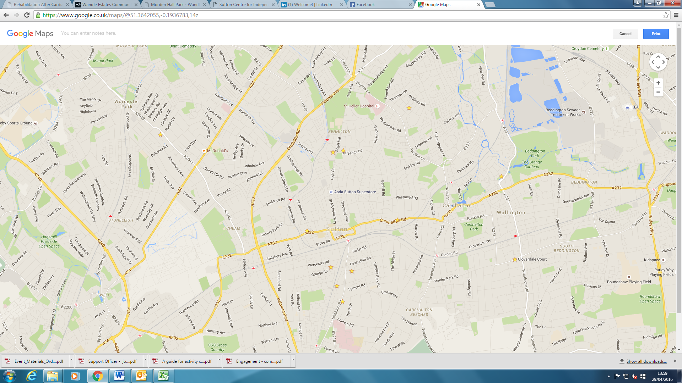
11
10
9
8
7
6
5
4
3
2
1
- Pat Shaw House | - Trickett House | - Robertson/Mary Court | - Thomas House | - Norman House
- Cloverdale Court | - Old Brewery House | - Lancelot House | - Margaret House | - Dorothy Pettingell House
- Griffiths Close
Cloverdale Court | 10-14 Stanley Park Road, Wallington, SM6 0EU
Dorothy Pettingell House | 6 Vermont Road, Sutton, SM1 3EQ
Griffiths Close | 209 Cheam Common Road, Worcester Park, KT4 8SL
Margaret House | 7 All Saints Road, Sutton, SM1 3DA
Norman House | 70 Cheam Road, Sutton, SM1 2SU
Old Brewery House | 294 London Road, Wallington, SM6 7DD
Robertson House | 1 Christchurch Park, Sutton, SM2 5TS
Thomas House | 20 Grange Road, Sutton, SM2 6RS
Trickett House | 125 Brighton Road, Sutton, SM2 5SN
SCHEME ADDRESS:

